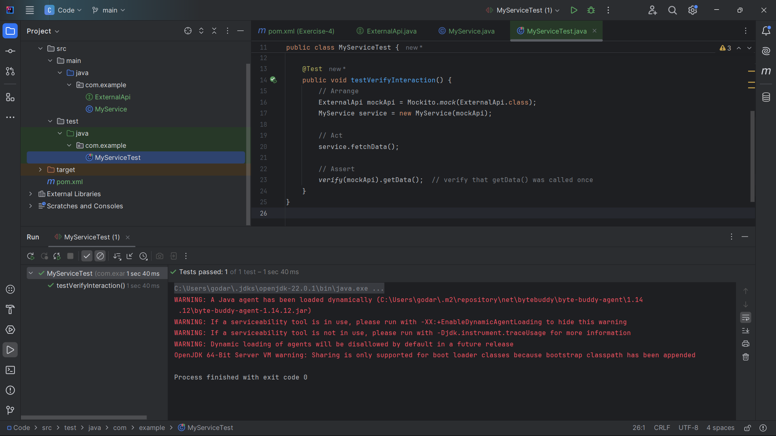**Terminal Output:**

C:\Users\godar\.jdks\openjdk-22.0.1\bin\java.exe -ea -Didea.test.cyclic.buffer.size=1048576 "-javaagent:C:\Program Files\JetBrains\IntelliJ IDEA Community Edition 2024.1.1\lib\idea_rt.jar=54997:C:\Program Files\JetBrains\IntelliJ IDEA Community Edition 2024.1.1\bin" -Dfile.encoding=UTF-8 -Dsun.stdout.encoding=UTF-8 -Dsun.stderr.encoding=UTF-8 -classpath "C:\Users\godar\.m2\repository\org\junit\platform\junit-platform-launcher\1.9.3\junit-platform-launcher-1.9.3.jar;C:\Program Files\JetBrains\IntelliJ IDEA Community Edition 2024.1.1\lib\idea_rt.jar;C:\Program Files\JetBrains\IntelliJ IDEA Community Edition 2024.1.1\plugins\junit\lib\junit5-rt.jar;C:\Program Files\JetBrains\IntelliJ IDEA Community Edition 2024.1.1\plugins\junit\lib\junit-rt.jar;C:\Users\godar\OneDrive\Desktop\Cognizant Deep Skilling\Week-2-JUnit_Mockito_SL4J_and_PL-SQL\JUnit_Mockito_and_SL4J\ Mockito_exercises\Exercise-2-Verifying_Interactions\Code\target\test-classes;C:\Users\godar\OneDrive\Desktop\Cognizant Deep Skilling\Week-2-JUnit_Mockito_SL4J_and_PL-SQL\JUnit_Mockito_and_SL4J\ Mockito_exercises\Exercise-2-Verifying_Interactions\Code\target\classes;C:\Users\godar\.m2\repository\org\junit\jupiter\junit-jupiter\5.9.3\junit-jupiter-5.9.3.jar;C:\Users\godar\.m2\repository\org\junit\jupiter\junit-jupiter-api\5.9.3\junit-jupiter-api-5.9.3.jar;C:\Users\godar\.m2\repository\org\opentest4j\opentest4j\1.2.0\opentest4j-1.2.0.jar;C:\Users\godar\.m2\repository\org\junit\platform\junit-platform-commons\1.9.3\junit-platform-commons-1.9.3.jar;C:\Users\godar\.m2\repository\org\apiguardian\apiguardian-api\1.1.2\apiguardian-api-1.1.2.jar;C:\Users\godar\.m2\repository\org\junit\jupiter\junit-jupiter-params\5.9.3\junit-jupiter-params-5.9.3.jar;C:\Users\godar\.m2\repository\org\junit\jupiter\junit-jupiter-engine\5.9.3\junit-jupiter-engine-5.9.3.jar;C:\Users\godar\.m2\repository\org\junit\platform\junit-platform-engine\1.9.3\junit-platform-engine-1.9.3.jar;C:\Users\godar\.m2\repository\org\mockito\mockito-core\5.11.0\mockito-core-5.11.0.jar;C:\Users\godar\.m2\repository\net\bytebuddy\byte-buddy\1.14.12\byte-buddy-1.14.12.jar;C:\Users\godar\.m2\repository\net\bytebuddy\byte-buddy-agent\1.14.12\byte-buddy-agent-1.14.12.jar;C:\Users\godar\.m2\repository\org\objenesis\objenesis\3.3\objenesis-3.3.jar" com.intellij.rt.junit.JUnitStarter -ideVersion5 -junit5 com.example.MyServiceTest

WARNING: A Java agent has been loaded dynamically (C:\Users\godar\.m2\repository\net\bytebuddy\byte-buddy-agent\1.14.12\byte-buddy-agent-1.14.12.jar)

WARNING: If a serviceability tool is in use, please run with -XX:+EnableDynamicAgentLoading to hide this warning

WARNING: If a serviceability tool is not in use, please run with -Djdk.instrument.traceUsage for more information

WARNING: Dynamic loading of agents will be disallowed by default in a future release

OpenJDK 64-Bit Server VM warning: Sharing is only supported for boot loader classes because bootstrap classpath has been appended

Process finished with exit code 0